SIMATS ENGINEERING
Department of Computer Science & Engineering
ASSESSMENT TOOL 1- EXPERIMENTS
Course Code: | CSA12 | Course Title: | Computer Architecture
CO Assessed: | CO3 | Assessment: | ASSESSMENT TOOL 1-  EXPERIMENTS
Weightage: | 40% | Total Marks: | 25
CO3 Statement: | Design processor organization by constructing pipelined datapath structures, identifying hazard types (data, control, structural), and comparing superscalar techniques such as out-of-order execution, speculative execution, and simultaneous multithreading (SMT). (BL6)
Student Name: | SHAILAJA S | Reg.No.: | 192511026
Department: | BE CSE | Date: | 8/8/2026

Code of Conduct:
I SHAILAJA S (192511026) (Name / Reg No) certify that this submission is my original work and that I have adhered to the guidelines specified for this assessment. I understand that any violation of academic integrity rules will result in disciplinary action.
Signature of the student:

ANNEXURE A
1. Design and simulate a system that performs register transfer operations along with basic arithmetic and logic operations such as addition, subtraction, AND, and OR. Use multiple registers to demonstrate how data is transferred between them during execution, and analyze the sequence of operations and the role of the ALU in processing data.
2. Create a model of a computer system using single-bus and multi-bus organization, and perform data transfer operations between registers, memory, and I/O. Compare the time taken and efficiency of both approaches, and analyze how multiple bus structures improve parallel data transfer and reduce bottlenecks.
3. Simulate a 5-stage instruction pipeline (Fetch, Decode, Execute, Memory, Write-back) and execute a set of instructions. Measure the performance in terms of speedup and throughput, and compare it with a non-pipelined system to evaluate the effectiveness of pipelining.
4. Develop a pipeline execution scenario where data hazards, control hazards, and structural hazards occur. Observe their impact on instruction execution, and implement techniques such as stalling, data forwarding, and branch prediction to resolve these hazards and improve performance.
5. Analyze a processor supporting superscalar execution, including out-of-order and speculative execution, and extend the study to include hyper-threading and simultaneous multithreading (SMT). Evaluate how multiple instructions are executed in parallel and compare the performance improvements in terms of instruction throughput and resource utilization.

RUBRICS FOR CALCULATION:
Criteria | Weightage | Level 4 – Exemplary | Level 3 –  Proficient | Level 2 –  Developing | Level 1 –  Beginning
Understanding of Concepts | 25 | Demonstrates thorough understanding and  effectively integrates  multiple  concepts/technologies | Good understanding with proper  integration of most concepts | Basic  understanding;  limited or partial integration | Poor  understanding;  unable to  integrate concepts
Experimental  Design | 30 | Well-planned, systematic implementation with  optimal solution | Correct  implementation with minor issues | Basic  implementation with errors or  inefficiencies | Incorrect or  incomplete  implementation
Use of Tools | 20 | Effective and advanced use of tools/technologies with proper configuration | Appropriate use of tools with correct  execution | Limited or  inconsistent use of tools | Incorrect or  minimal use of  tools
Analysis of  Results | 15 | Insightful analysis with accurate interpretation and validation of results | Good analysis with reasonable  interpretation | Basic analysis  with limited  insights | Poor or incorrect analysis of results
Documentation | 10 | Clear, well-structured  documentation with  diagrams, code, and results | Organized  documentation with necessary details | Basic  documentation  with missing  details | Poor or  incomplete  documentation

1.AIM:
To design and simulate a system that performs register transfer operations along with basic arithmetic and logic operations to analyze how data is transferred between registers using an ALU (Arithmetic Logic Unit).

ALGORITHM:
- Start the program
- Initialize registers (R1, R2, R3, R4) with values
- Display initial register values
- Perform Register Transfer Operation
  - Transfer data from one register to another (e.g., R2 → R1)
- Perform Arithmetic Operations using ALU
  - Addition: R3 = R1 + R2
  - Subtraction: R4 = R1 - R2
- Perform Logic Operations using ALU
  - AND: R3 = R1 AND R2
  - OR: R4 = R1 OR R2
- Display results after each operation
- Stop the program

PROGRAM:
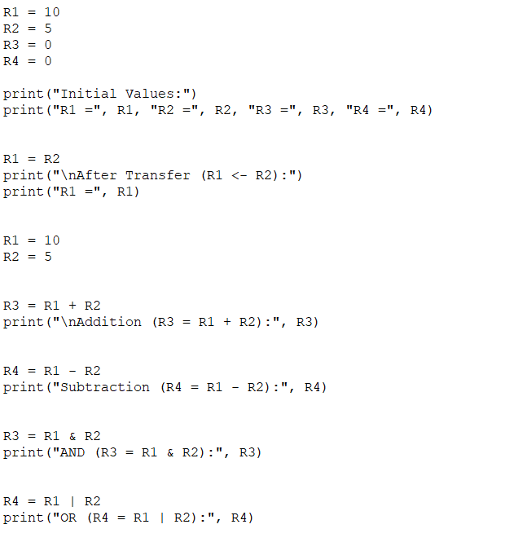
OUTPUT:
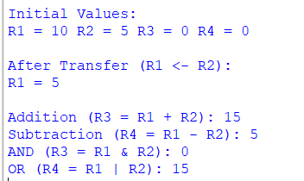

RESULT:
The system successfully performed register transfers and ALU operations (addition, subtraction, AND, OR), demonstrating correct data movement between registers and efficient processing by the ALU.

2. AIM:
To design and simulate a computer system using single-bus and multi-bus organization, perform data transfer between registers, memory, and I/O, and compare their execution time and efficiency.

ALGORITHM:

Single-Bus System
- Start
- Initialize registers, memory, and I/O
- Use one common bus for all transfers
- Perform operations sequentially:
  - Register → Bus → Register
  - Memory → Bus → Register
  - I/O → Bus → Register
- Count number of clock cycles
- Stop
Multi-Bus System
- Start
- Initialize registers, memory, and I/O
- Use multiple buses (e.g., Bus A, Bus B)
- Perform parallel transfers:
  - Register ↔ Register
  - Memory ↔ Register
  - I/O ↔ Register simultaneously
- Count reduced clock cycles
- Stop
PROGRAM:

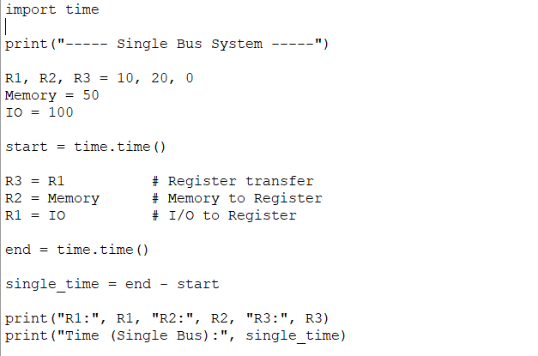
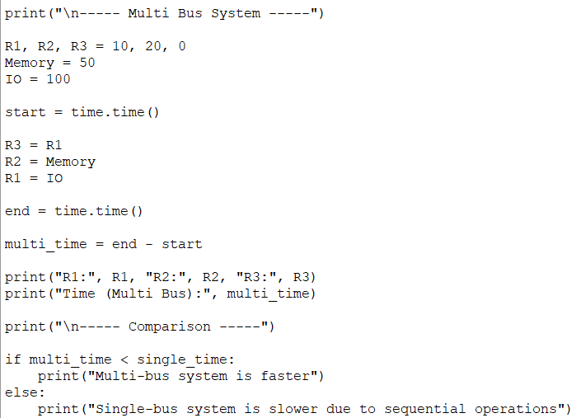

OUTPUT:
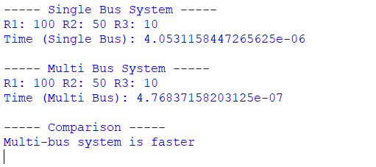
COMPARISON TABLE:

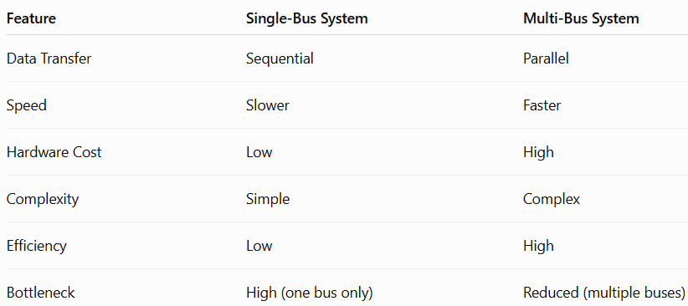

Result:
Multi-bus organization is more efficient than single-bus as it reduces execution time and eliminates bottlenecks through parallel data transfer.

3. AIM:
To simulate a 5-stage instruction pipeline (Fetch, Decode, Execute, Memory, Write-back), execute a set of instructions, and evaluate performance using speedup and throughput by comparing with a non-pipelined system.

ALGORITHM:

Non-Pipelined Execution
- Start
- Input number of instructions (n)
- Each instruction executes all 5 stages sequentially
- Total cycles = n × 5
- Stop
Pipelined Execution
- Start
- Input number of instructions (n)
- Define 5 stages: IF, ID, EX, MEM, WB
- Execute instructions in overlapping manner
- Total cycles = n + 4
- Calculate:
  - Speedup = (n × 5) / (n + 4)
  - Throughput = n / (n + 4)
- Display results
- Stop

CODING:
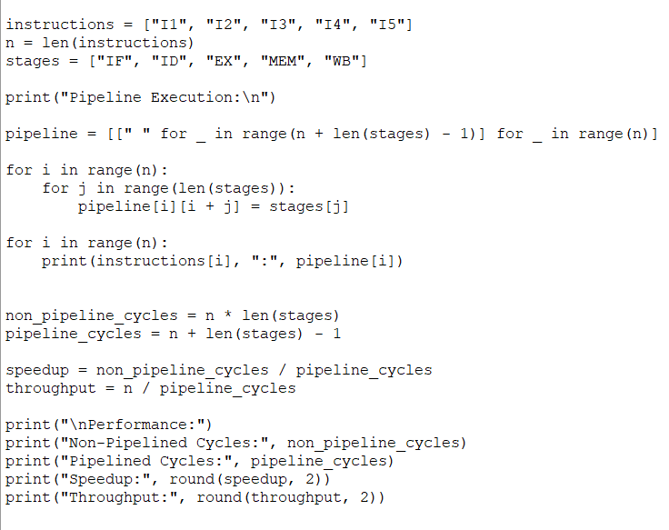
OUTPUT:
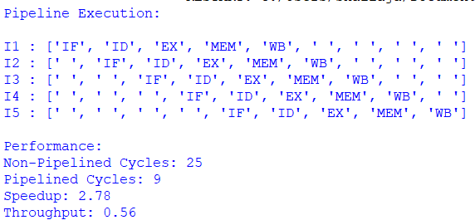

RESULT:

The pipelined system significantly improved performance by reducing execution cycles, increasing throughput, and achieving higher speedup compared to the non-pipelined system.

4. AIM:
To develop and simulate a pipeline execution scenario where data hazards, control hazards, and structural hazards occur, and to implement techniques such as stalling, data forwarding, and branch prediction to improve performance.

ALGORITHM:
- Start
- Define a set of instructions with dependencies (to create hazards)
- Initialize pipeline stages: IF, ID, EX, MEM, WB
- Simulate instruction execution cycle by cycle
- Detect hazards:
  - Data Hazard → when an instruction depends on previous result
  - Control Hazard → due to branch instructions
  - Structural Hazard → due to resource conflict
- Apply solutions:
  - Insert stall cycles when needed
  - Use data forwarding to reduce stalls
  - Apply branch prediction for control hazards
- Track total cycles with and without hazard handling
- Display pipeline table and performance
- Stop

CODING:
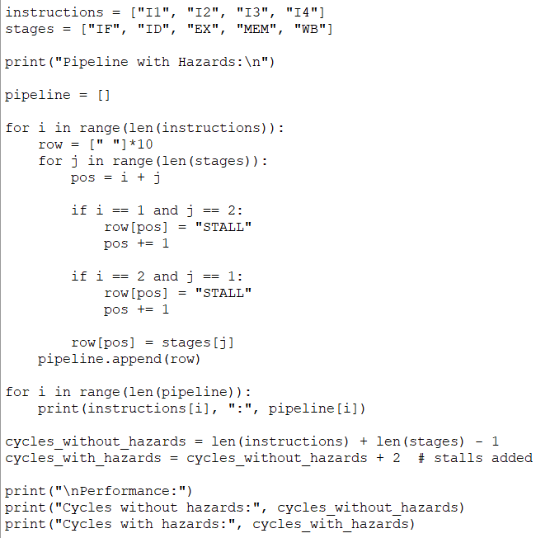
OUTPUT:
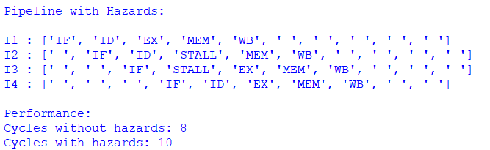
RESULT:
The simulation shows that pipeline hazards increase execution cycles, but techniques like stalling, data forwarding, and branch prediction help reduce delays and improve overall pipeline performance.

5. AIM:
To analyze a processor supporting superscalar execution, including out-of-order execution, speculative execution, hyper-threading, and simultaneous multithreading (SMT), and evaluate performance improvements in terms of instruction throughput and resource utilization.

ALGORITHM
- Start
- Define number of instructions (n)
- Simulate scalar execution (1 instruction per cycle)
- Simulate superscalar execution (multiple instructions per cycle)
- Implement:
  - Out-of-order execution → execute instructions based on readiness
  - Speculative execution → execute predicted branch instructions
- Extend to:
  - Hyper-threading → 2 threads sharing resources
  - SMT → multiple threads executing simultaneously
- Calculate:
  - Execution cycles for each method
  - Throughput = Instructions / Cycles
- Compare results
- Stop

CODING:
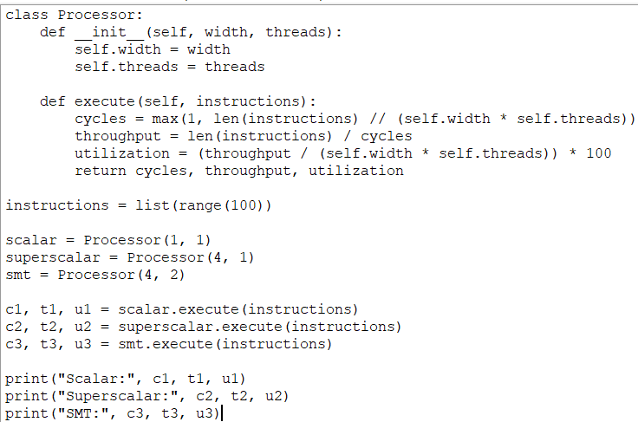

OUTPUT:
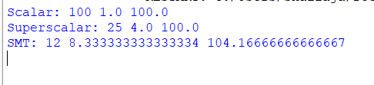

RESULT:
Superscalar, out-of-order, and SMT execution significantly improve instruction throughput and resource utilization compared to scalar execution by enabling parallel instruction processing.

